|  |
| --- |
|  |



FlyAway+

**Report #1 – Project Introduction**

**Project Code: FAP**

**Document Code: FAP_Introduction_EN**

**- Hanoi, 05/2015 -**

# INTRODUCTION

## Purpose

This document is created as the introduction for project FlyAway+ – our Capstone Project at FPT University. In this document, we will descript the **overview of some existing systems**, the **initial idea for our project**, a brief description about our **expected system and some potential risks, critical assumptions**, **constrains**. Moreover, this document also shows **opportunities** what it offers for users.

## Acronyms and Definitions

|  |  |
| --- | --- |
| Acronym & Abbreviation | Definition |
| FAP | FlyAway+ |
| FU | FPT University |
| Q&A | Question and Answer |
|  |  |
|  |  |

**Table 1-1:** Definitions and Acronyms

# ABSTRACT

Nowadays, there are many social networks are using by billions of people. Facebook, Twitter, Tumblr are the most famous social networks. As of the first quarter of 2015, Market leader Facebook was the first social network to surpass 1 billion registered accounts, tenth-ranked microblogging network Twitter had over 288 million monthly active accounts. Meanwhile, blogging service Tumblr had more than 230 million active blog users on their site. On social networks, every day we can see many people share photos, post about their trips around the world, between millions of other things like school, family, works etc…Our website is developed by travel-lovers with the aim of helping users **to share their** experiences about their trips, keeps beautiful memories and connecting people by travelling.

# LITERATURE REVIEW

Facebook, Twitter and Tumblr etc…are popular social networks. However still have no social network are just about travelling. There are many websites about travelling, but most of them aim to booking tickets, flights, tours with good deals, or advertisements, people cannot be connected and keeps memories about their own trips on these website. For example: wego.vn, budgettravel.com…

**Facebook**

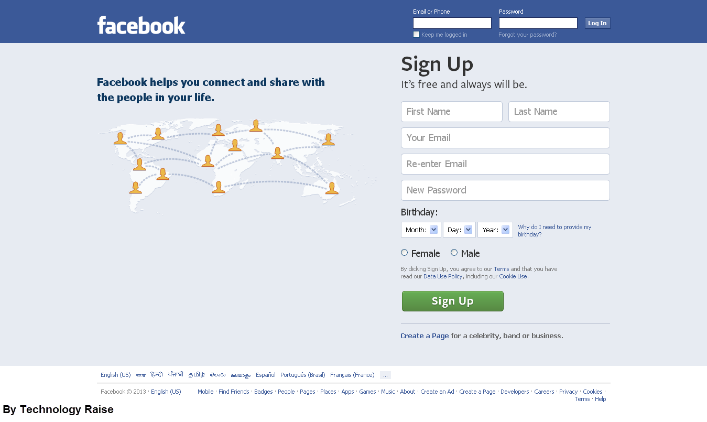

Facebook is an online social networking service, users can create a [user profile](http://en.wikipedia.org/wiki/User_profile), add other users as ["friends"](http://en.wikipedia.org/wiki/Friending), exchange messages, post status updates and photos, share videos and receive notifications when others update their profiles.

*Advantages:*

* Is a global social networking site available in various languages
* Helped a lot to create a personal brand for many individuals and for business.
* Easy to find friends, college, like-minded people
* Hosting site for images and videos
* Source of information and news

*Disadvantages:*

* Too many un-useful information
* Time consuming

**tumbrl.**

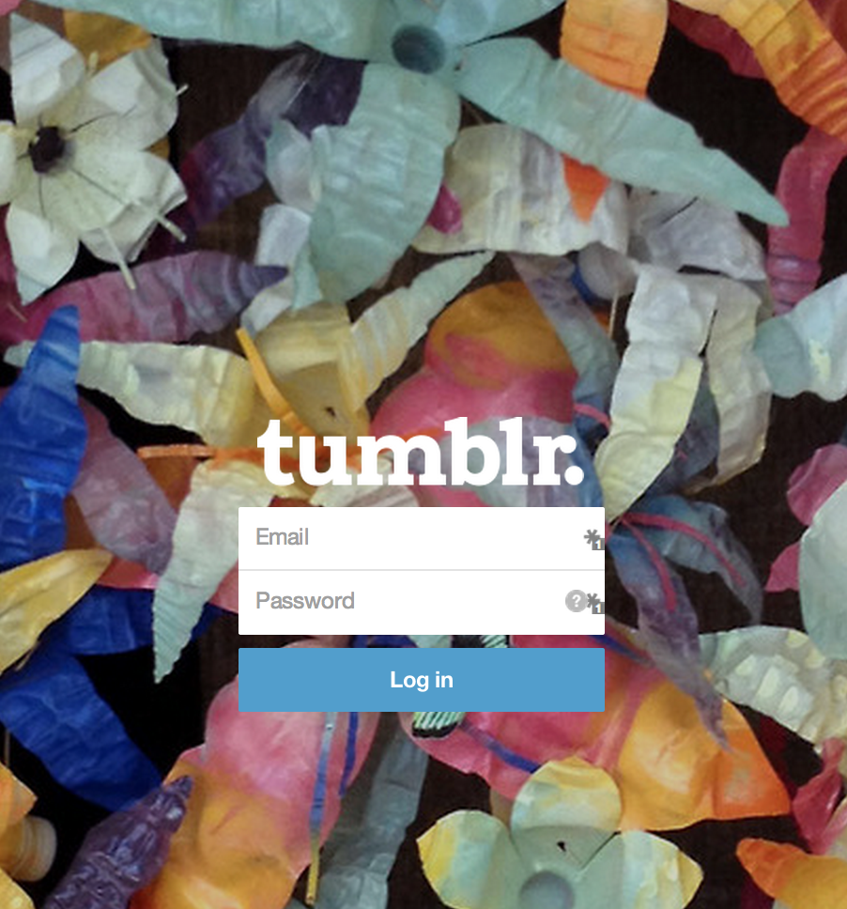

Tumblr is a [microblogging](http://en.wikipedia.org/wiki/Microblogging) platform and [social networking](http://en.wikipedia.org/wiki/Social_networking_service) website. Users can follow other users' blogs, as well as make their blogs private.

*Advantages:*

* Is very user friendly; with no coding experience needed. Simply add content and click button to upload.
* Gives its users the option to incorporate Google analytics so they can track the effectiveness of their posts and visitor numbers.
* Allows users to optimize posts for SEO purposes through the use of keywords and automatically indexes them with Google search.

*Disadvantages:*

* Is mostly used for sharing images and video.
* Is known to have stability issues, resulting in a lot of downtime.
* Posts are difficult to optimize for Search Engine Optimization (SEO).

**WeGo.vn**

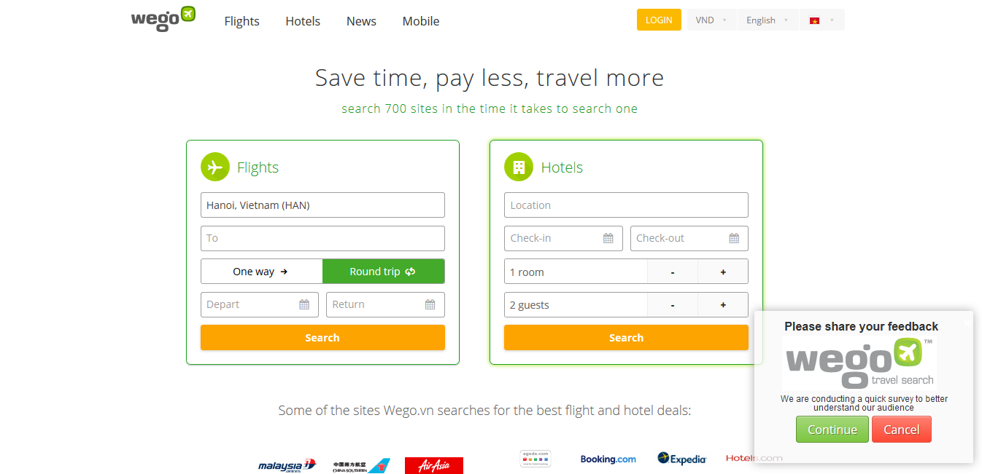

*Advantages:*

*Disadvantages:*

**BudgetTravel.com**

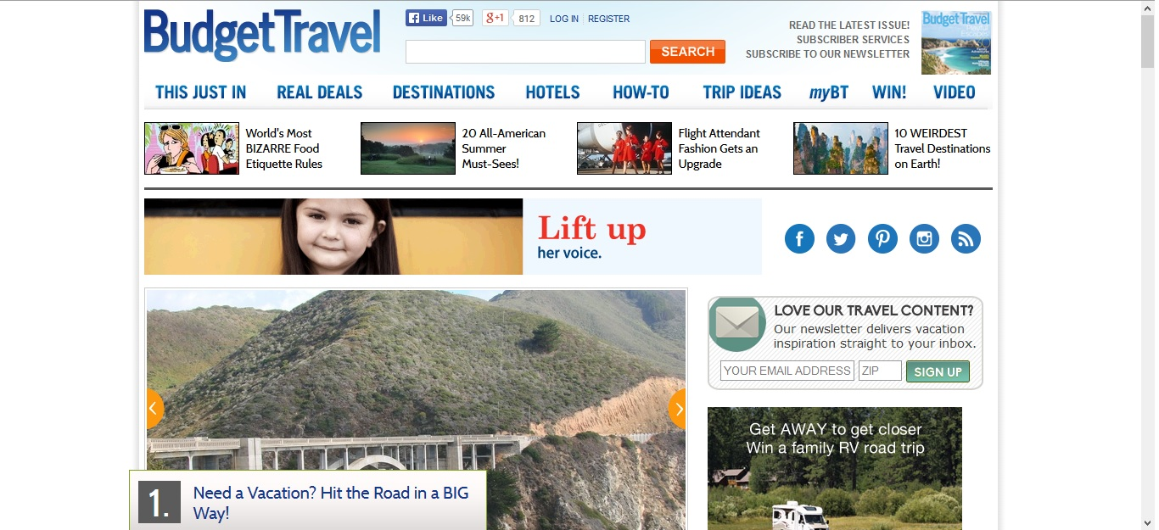

*Advantages:*

*Disadvantages:*

# PROPOSAL

## The idea

## Objectives

This project is the Capstone Project in FPT University studying program.

First, this project is responsibility for all team members. So we must complete all requirements from teacher and FU. During the time doing project, we can learn how to develop a project, how to manage project, how to communicate better between team member, how to control time, how to perform teamwork effectively. Moreover, we also have experience about .NET, website design, test website… Therefore, we think this project is very necessary for us to improve skills, knowledge which we studied in FU. This project also makes our CV more beautiful after graduating from FU. This is also an opportunity for us to prove capacity with recruiters.

Second, because we love travel. When we go to new places, we want to share with people experiences we have lived, things we have done, where and what we have eaten. People can make new friends by join in groups, FlyAway+ and have new experiences together. We hope we can share all we have, and we hope people who loves travel can be connected and easily share information about their trips.

## Brief description about system

This software is a web application. With friendly and simple interface, users can easily find out what they want without registration. User also can send opinion to admin if there is anything that needs to be modified.

FAP uses familiar technologies as: JavaScript, ASP.NET…And we are planning to develop a mobile version for easily sharing and connecting.

## System features

About the features of FAP, we focus to provide for users main features as searching, sharing posts, photos and videos, check-in, scheduling their trips, reading others’ posts, connecting and interacting to other travelers etc…Admin can manage members, manage database, manage contribute database and manage Q&A.

In here, we focus on features which can help users can understand the best way what user want to have with features of FAP. There are the detailed features of FAP:

* **Search**: User and guest can search for places, food and drinks, experiences or friends and FAP will display results match with words user have searched. With searching features, user can easily search information of places they want to go, things they can experience at this places, and finding people who want to go to this place. The very new point and useful of FAP when compare with others is FAP is not only show the results match with words user have search but also show things related. User have the following searching option:
  + Searching with name of places: user can search with name of a place and FAP will display information about place(s), things related to this places (post, photos, reviews, suggestion etc…), friends and other users are going to/went to this place(s). FAP will also suggest rooms for user (information about room features are below)
  + Searching with name of friends, group or another user: user can search with name of friends, groups or another users (who is not friend with user), FAP will display basic information of user and link to user’s homepage
  + Searching with name of food, drinks, or activities (skies, swimming, diving…): user can search with name of food, drinks or activities…and FAP will suggest places to enjoying. FAP will also suggest like-minded people.
* **Registering:** User can register an account and login to use all features of FAP
* **Sharing:** Registered user can share their post, photos and videos about their trips.
  + **Post**
  + **Photos**
  + **Videos**
  + **Write a review**
  + **Like/dislike and comment**
  + **Report**
* **Room:** This is a new useful features of FAP for connecting users.
  + **Create a room**
  + **Manage members of room:** User who create rooms is administrator of this room. Admin of a room can set another to admin to manage resources and member of room.
  + **Join to others’ rooms:** There are private room and public room.
    - **Private room:**
    - **Public room:**
* **Managing account:** Registered user can add, edit information
  + **Login/Logout**: User can login to use more features of FAP. User can register an account to login or login by using Facebook, Google account.
  + **Changing password/Forgetting password**: User can change new password or require new password if user forgot current password.
  + **Privacy**: User can choose who can see things on their homepage.
* **Managing member**: Admin can review report sent from users. If the report is reasonable, admin can delete post, send warning to user who has reported, admin can also lock/unlock users’ account.

# BENEFIT FROM PROJECT

## For our group

After developing and implementing this project, our group will get some benefits:

* Have more experiences of managing a software project: how to manage plan, time, member and risk.
* Have more knowledge and skill about .NET programming
* Know how to communicate with team members and how to teamwork more effective.
* Have more knowledge about managing and travelling.
* Have mark in Capstone Project

## For Community

Just need to have a device that connect to the internet and any web browser, user can:

* Easy join to a community of travel-lovers
* Easy search for places information and connect to friends
* Easy share and keep memories of their trips
* Create an online passport to show where they went to
* Find more friends
* Simply add content and click button to upload.
* Users do not need to pay money for using. It is completely free for all users.

# CRITICAL ASSUMPTION AND CONSTRAINTS

# POTENTIAL RISKS

After studying about this project, we find out some problem that we may be encountered:

* Lack of experience in exchange information, managing and controlling work so we may be miss the deadline or under estimate scope, time.
* Lack of knowledge and experience in the framework and technique of .NET and web. Therefore, we have to study all of them from the beginning. The project team may face with the difficult technical problems that may requires long time to resolve so that causes the project be delayed.
* Lack of knowledge and experience in managing.
* Sometime, because of careless, team members can lose data, source code… before uploading data to server.

# REFERENCES

**[1] Facebook at URL**  <http://www.facebook.com/>

**[2] Tumblr at URL** <https://www.tumblr.com/>

**[2] WeGo at URL** <http://www.wego.vn/>

**[3] BudgetTravel at URL**  <http://www.budgettravel.com/>